**MOVIE MANAGEMENT SYSTEM**

**PROBLEM STATEMENT:**

In this project our goal is to create a Movie Management System for easy booking of tickets, view movies according to their genre, their language and also allow canceling a booking of a ticket, view the ratings of the movie and filter the movies according to the ratings.

**Description Overview:**

A Movie Management System is a software application designed to help organize and manage information related to movies. This system typically targets film industry professionals, movie enthusiasts, and those involved in the production, distribution, and exhibition of movies. This article aims to provide all the information related to a set of movies such as the genre of the movie, language of the movie and the ratings according to the movie also allowing the users to book a movie ticket according to their locality, screen type, number of tickets needed also allowing them to select a perfect time to watch the movie. Later it also allows the user to cancel the movie tickets if there is any change of plans. This can be used on any application where it is being implemented along with a suitable template and user friendly appearance.

Movie booking platforms have made the movie booking technique more efficient allowing users to book tickets online and more efficiently view if the seats are available according to their specific time. Some of the movie booking now include: book_my_show, paytm, INOX, PVR Cinemas, etc.

Some of the apps allow users to view movie online (movies that have already been released) according the genre the users want to watch the movie in also to filter according to their language that best suits them. They also allow them to view a particular movie rating also allowing filtering the movies according to the ratings. Some of the apps that consider all this properties include are: Jio Cinema, Disney plus Hot-star, Torrent, etc.

**Technology Use:**

Here we will be using **Anaconda Python 3.6 or Pycharm 3.3.12 platform** to code our programwith the use of different python functions to perform the operations needed to achieve the above mentioned tasks or operations to be achieved.

**INSTALLATION:**

Installation of this project is pretty easy. Please do follow the following steps to create a virtual environment and perform the following functions according to your needs.

**In Jupyter Notebook it’s easy:**

1. **Install Jupyter Notebook on your system using the command “pip install jupyter notebook” .**
2. **Then click on new and select “Python3 (ipy kernel)”.**
3. **Using your programming skills start creating your project.**

**In Pycharm it’s easy:**

1. **Download pycharm’s current version from the browser.**
2. **Install the necessary packages and other necessary libraries when the download or installation is in process.**
3. **Then click on new from the file option that is present in the menu bar and select Python Notebook from the options being present.**
4. **Finally using your programming skills start creating your project using the different operations and functions that is going to be performed in a movie management system.**

**Workflow diagram**

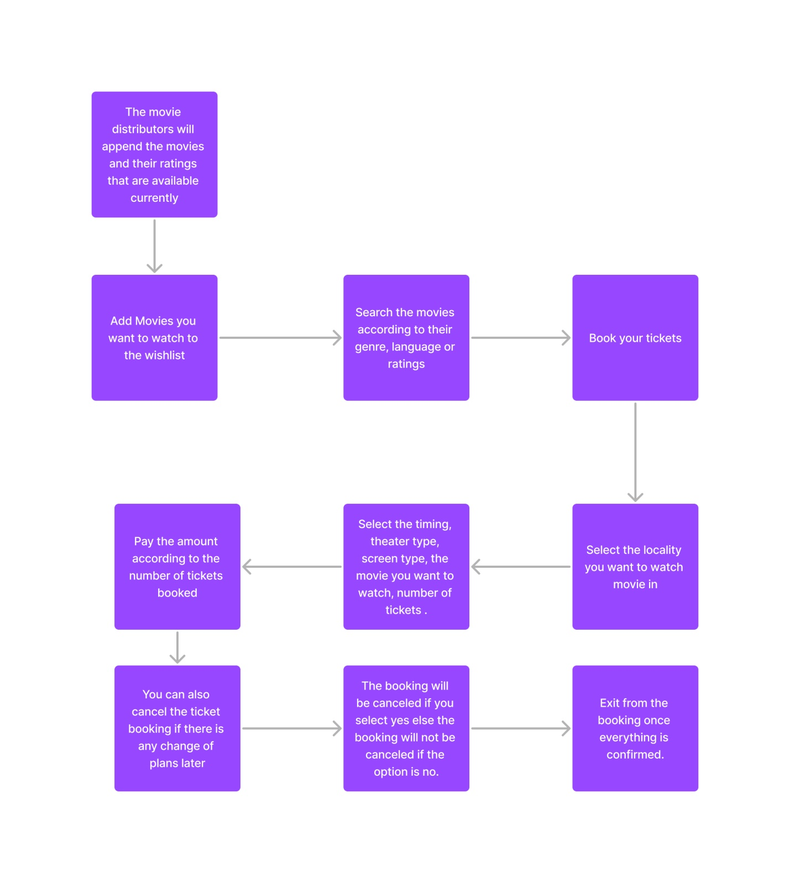

**Implementation:**

1. **Project Directory:**

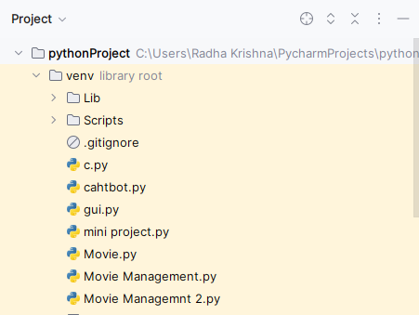

**This is project structure.**

1. **Movie Management.py:**

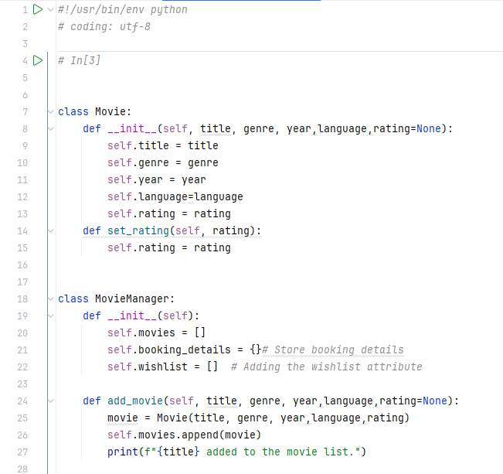

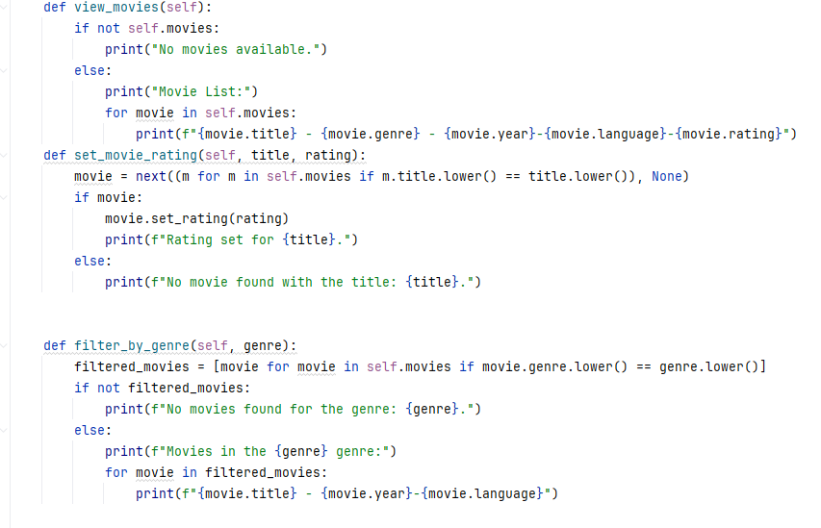

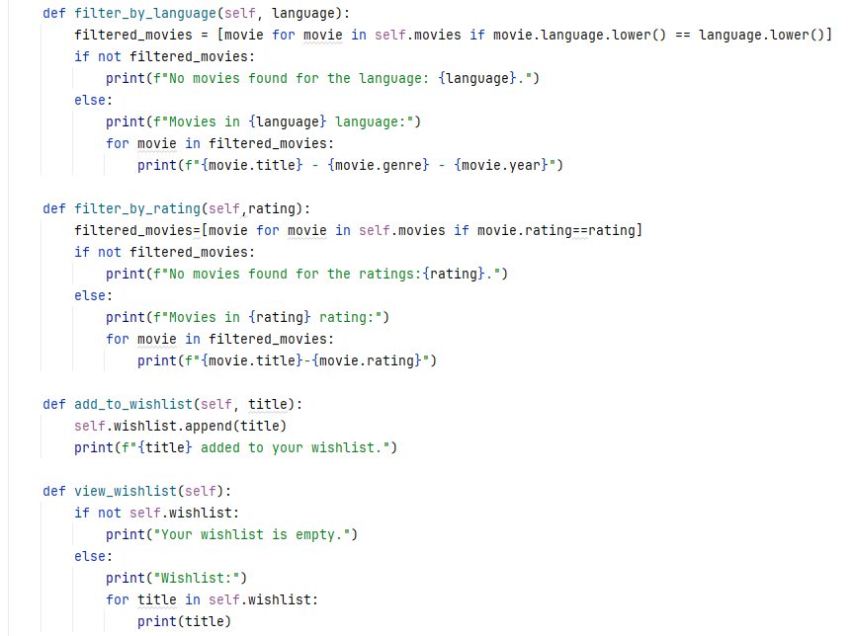

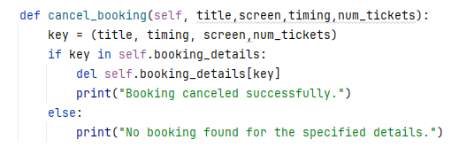

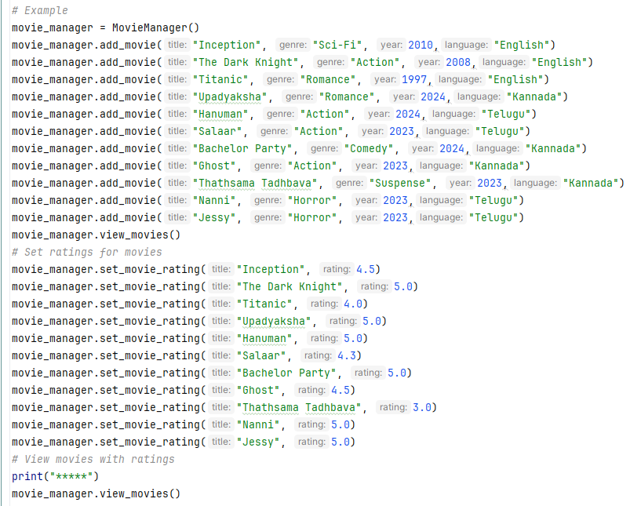

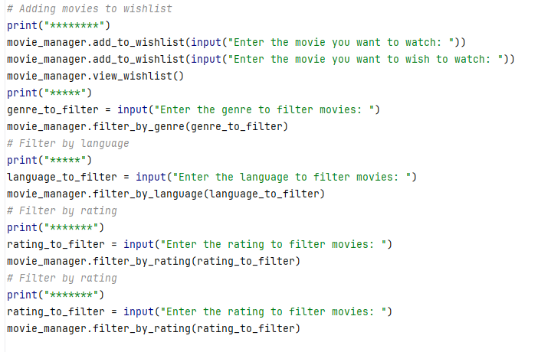

1. **Booking Movie ticket:**

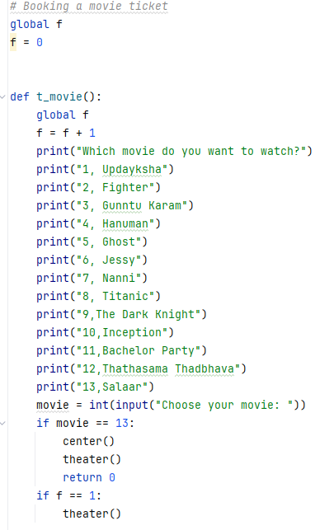

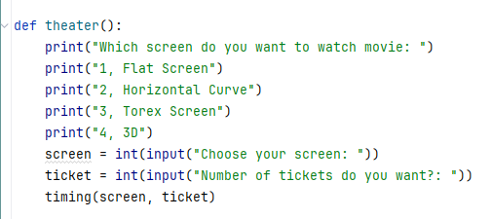

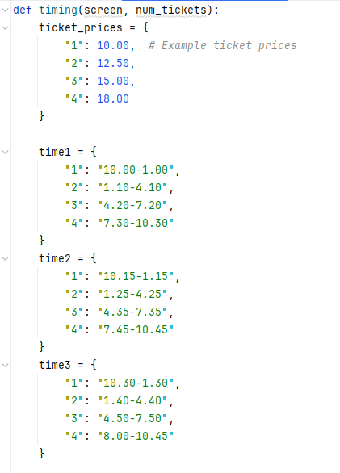

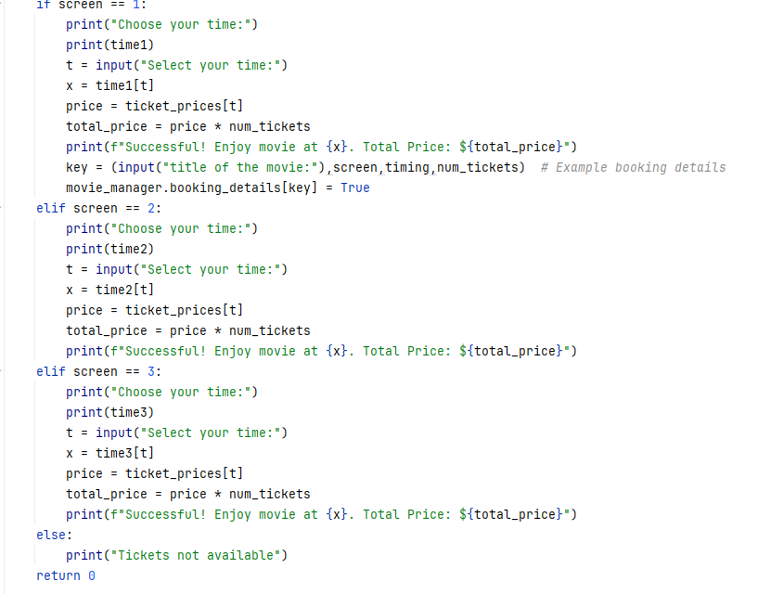

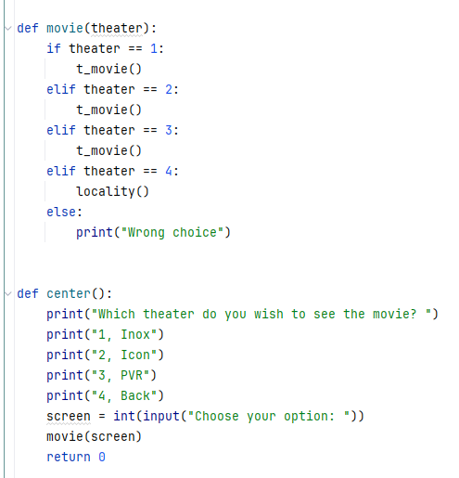

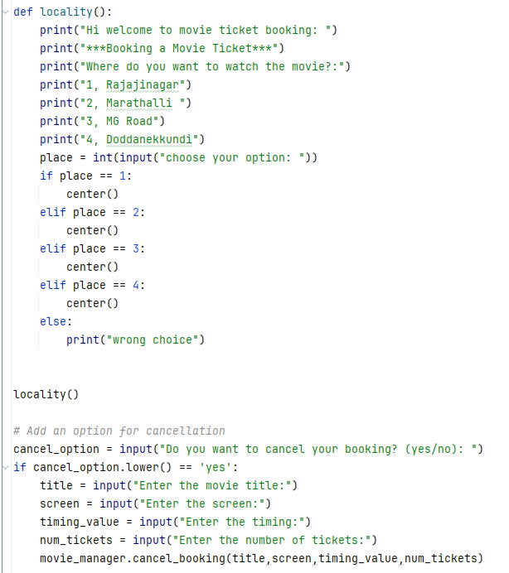

**This contains the code for viewing the movies available with filtering options according to genre, language and rating alsong with movie ticket booking.**

**Testing the program code:**

To run this project in your local system just run the file Movie Management.py and the result will be obtained.

**"C:\Users\Radha Krishna\PycharmProjects\pythonProject\venv\Scripts\python.exe" "C:\Users\Radha Krishna\Downloads\Movie Management.py"**

**Inception added to the movie list.**

**The Dark Knight added to the movie list.**

**Titanic added to the movie list.**

**Upadyaksha added to the movie list.**

**Hanuman added to the movie list.**

**Salaar added to the movie list.**

**Bachelor Party added to the movie list.**

**Ghost added to the movie list.**

**Thathsama Tadhbava added to the movie list.**

**Nanni added to the movie list.**

**Jessy added to the movie list.**

**Movie List:**

**Inception - Sci-Fi - 2010-English-None**

**The Dark Knight - Action - 2008-English-None**

**Titanic - Romance - 1997-English-None**

**Upadyaksha - Romance - 2024-Kannada-None**

**Hanuman - Action - 2024-Telugu-None**

**Salaar - Action - 2023-Telugu-None**

**Bachelor Party - Comedy - 2024-Kannada-None**

**Ghost - Action - 2023-Kannada-None**

**Thathsama Tadhbava - Suspense - 2023-Kannada-None**

**Nanni - Horror - 2023-Telugu-None**

**Jessy - Horror - 2023-Telugu-None**

**Rating set for Inception.**

**Rating set for The Dark Knight.**

**Rating set for Titanic.**

**Rating set for Upadyaksha.**

**Rating set for Hanuman.**

**Rating set for Salaar.**

**Rating set for Bachelor Party.**

**Rating set for Ghost.**

**Rating set for Thathsama Tadhbava.**

**Rating set for Nanni.**

**Rating set for Jessy.**

**\*\*\*\*\***

**Movie List:**

**Inception - Sci-Fi - 2010-English-4.5**

**The Dark Knight - Action - 2008-English-5.0**

**Titanic - Romance - 1997-English-4.0**

**Upadyaksha - Romance - 2024-Kannada-5.0**

**Hanuman - Action - 2024-Telugu-5.0**

**Salaar - Action - 2023-Telugu-4.3**

**Bachelor Party - Comedy - 2024-Kannada-5.0**

**Ghost - Action - 2023-Kannada-4.5**

**Thathsama Tadhbava - Suspense - 2023-Kannada-3.0**

**Nanni - Horror - 2023-Telugu-5.0**

**Jessy - Horror - 2023-Telugu-5.0**

**\*\*\*\*\*\*\*\***

**Enter the movie you want to watch: Home Alone**

**Home Alone added to your wishlist.**

**Enter the movie you want to wish to watch: Cuttputli**

**Cuttputli added to your wishlist.**

**Wishlist:**

**Home Alone**

**Cuttputli**

**\*\*\*\*\***

**Enter the genre to filter movies: horror**

**Movies in the horror genre:**

**Nanni - 2023-Telugu**

**Jessy - 2023-Telugu**

**\*\*\*\*\***

**Enter the language to filter movies: kannada**

**Movies in kannada language:**

**Upadyaksha - Romance - 2024**

**Bachelor Party - Comedy - 2024**

**Ghost - Action - 2023**

**Thathsama Tadhbava - Suspense - 2023**

**\*\*\*\*\*\*\***

**Enter the rating to filter movies: 0.5**

**No movies found for the ratings:0.5.**

**\*\*\*\*\*\*\***

**Enter the rating to filter movies: 3.5**

**No movies found for the ratings:3.5.**

**Hi welcome to movie ticket booking:**

**\*\*\*Booking a Movie Ticket\*\*\***

**Where do you want to watch the movie?:**

**1, Rajajinagar**

**2, Marathalli**

**3, MG Road**

**4, Doddanekkundi**

**choose your option: 1**

**Which theater do you wish to see the movie?**

**1, Inox**

**2, Icon**

**3, PVR**

**4, Back**

**Choose your option: 1**

**Which movie do you want to watch?**

**1, Updayksha**

**2, Fighter**

**3, Gunntu Karam**

**4, Hanuman**

**5, Ghost**

**6, Jessy**

**7, Nanni**

**8, Titanic**

**9,The Dark Knight**

**10,Inception**

**11,Bachelor Party**

**12,Thathasama Thadbhava**

**13,Salaar**

**Choose your movie: 1**

**Which screen do you want to watch movie:**

**1, Flat Screen**

**2, Horizontal Curve**

**3, Torex Screen**

**4, 3D**

**Choose your screen: 1**

**Number of tickets do you want?: 3**

**Choose your time:**

**{'1': '10.00-1.00', '2': '1.10-4.10', '3': '4.20-7.20', '4': '7.30-10.30'}**

**Select your time:4**

**Successful! Enjoy movie at 7.30-10.30. Total Price: $54.0**

**title of the movie:Upadyaksha**

**Do you want to cancel your booking? (yes/no): no**

**Process finished with exit code 0**

**Conclusion:**

Hence, we have successfully viewed the movies and booked the tickets according to our schedule.

**Comparison:**

**We have developed a platform that is different from all other booking platforms and methods.**